Wizard of Oz Advertising Opportunities
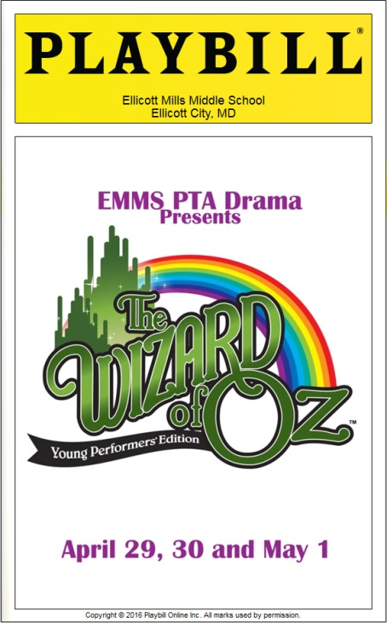
This year Ellicott Mills Middle School will be producing Wizard of Oz. Our program this year will be printed by the same company that professionally prints the Playbills that you see in NYC theatres. That said, this year’s Playbill will look grand and will most certainly become a keepsake for years to come. In addition to the people who see the Playbill during the performances, this program will be shown to family and friends after the fact. PLUS, we will have an online version that will last forever.
With all that, this year’s advertisers are certainly getting a good bang for their buck.
So sign up today to advertise in the EMMIS Playbill for Wizard of Oz.
Show Dates: April 29 & 30 and May 1, 2016
Location: Ellicott Mills Middle School
Costs:
- ¼ Page Black and White = $25
- ½ Page Black and White = $50
- Full Page Black and White = $100
Specs:
- ¼ Page = 2.5” wide x 4” long
- ½ Page = 5” wide x 4” long
- Full Page = 5” wide x 8” long

Ad Deadlines: Friday, March 25
Artwork and order can be submitted in person or sent electronically to:
Becky Daugherty at emmsdramaprodteam@gmail.com

